**Neural Network Basics**

**LATEST SUBMISSION GRADE**

100%

1.Question 1

What does a neuron compute?



A neuron computes a linear function (z = Wx + b) followed by an activation function



A neuron computes an activation function followed by a linear function (z = Wx + b)



A neuron computes a function g that scales the input x linearly (Wx + b)



A neuron computes the mean of all features before applying the output to an activation function

**Correct**

Correct, we generally say that the output of a neuron is a = g(Wx + b) where g is the activation function (sigmoid, tanh, ReLU, ...).

**1 / 1 point**

2.Question 2

Which of these is the "Logistic Loss"?



\mathcal{L}^{(i)}(\hat{y}^{(i)}, y^{(i)}) = \mid y^{(i)} - \hat{y}^{(i)} \midL(*i*)(*y*^​(*i*),*y*(*i*))=∣*y*(*i*)−*y*^​(*i*)∣



\mathcal{L}^{(i)}(\hat{y}^{(i)}, y^{(i)}) = max(0, y^{(i)} - \hat{y}^{(i)})L(*i*)(*y*^​(*i*),*y*(*i*))=*max*(0,*y*(*i*)−*y*^​(*i*))



\mathcal{L}^{(i)}(\hat{y}^{(i)}, y^{(i)}) = -( y^{(i)}\log(\hat{y}^{(i)}) + (1- y^{(i)})\log(1-\hat{y}^{(i)})L(*i*)(*y*^​(*i*),*y*(*i*))=−(*y*(*i*)log(*y*^​(*i*))+(1−*y*(*i*))log(1−*y*^​(*i*)))



\mathcal{L}^{(i)}(\hat{y}^{(i)}, y^{(i)}) = \mid y^{(i)} - \hat{y}^{(i)} \mid^{2}L(*i*)(*y*^​(*i*),*y*(*i*))=∣*y*(*i*)−*y*^​(*i*)∣2

**Correct**

Correct, this is the logistic loss you've seen in lecture!

**1 / 1 point**

3.Question 3

Suppose img is a (32,32,3) array, representing a 32x32 image with 3 color channels red, green and blue. How do you reshape this into a column vector?



x = img.reshape((32*32,3))



x = img.reshape((32*32*3,1))



x = img.reshape((1,32*32,*3))



x = img.reshape((3,32*32))

**Correct**

**1 / 1 point**

4.Question 4

Consider the two following random arrays "a" and "b":



1

2

3

a = np.random.randn(2, 3) # a.shape = (2, 3)

b = np.random.randn(2, 1) # b.shape = (2, 1)

c = a + b

What will be the shape of "c"?



c.shape = (3, 2)



c.shape = (2, 1)



c.shape = (2, 3)



The computation cannot happen because the sizes don't match. It's going to be "Error"!

**Correct**

Yes! This is broadcasting. b (column vector) is copied 3 times so that it can be summed to each column of a.

**1 / 1 point**

5.Question 5

Consider the two following random arrays "a" and "b":



1

2

3

a = np.random.randn(4, 3) # a.shape = (4, 3)

b = np.random.randn(3, 2) # b.shape = (3, 2)

c = a*b

What will be the shape of "c"?



c.shape = (3, 3)



The computation cannot happen because the sizes don't match. It's going to be "Error"!



c.shape = (4,2)



c.shape = (4, 3)

**Correct**

Indeed! In numpy the "*" operator indicates element-wise multiplication. It is different from "np.dot()". If you would try "c = np.dot(a,b)" you would get c.shape = (4, 2).

**1 / 1 point**

6.Question 6

Suppose you have n_x*nx*​ input features per example. Recall that X = [x^{(1)} x^{(2)} ... x^{(m)}]*X*=[*x*(1)*x*(2)...*x*(*m*)]. What is the dimension of X?



(m,n_x)(*m*,*nx*​)



(n_x, m)(*nx*​,*m*)



(m,1)(*m*,1)



(1,m)(1,*m*)

**Correct**

**1 / 1 point**

7.Question 7

Recall that "np.dot(a,b)" performs a matrix multiplication on a and b, whereas "a*b" performs an element-wise multiplication.

Consider the two following random arrays "a" and "b":



1

2

3

a = np.random.randn(12288, 150) # a.shape = (12288, 150)

b = np.random.randn(150, 45) # b.shape = (150, 45)

c = np.dot(a,b)

What is the shape of c?



c.shape = (12288, 150)



c.shape = (150,150)



c.shape = (12288, 45)



The computation cannot happen because the sizes don't match. It's going to be "Error"!

**Correct**

Correct, remember that a np.dot(a, b) has shape (number of rows of a, number of columns of b). The sizes match because :

"number of columns of a = 150 = number of rows of b"

**1 / 1 point**

8.Question 8

Consider the following code snippet:



1

2

3

4

5

6

# a.shape = (3,4)

# b.shape = (4,1)

for i in range(3):

for j in range(4):

c[i][j] = a[i][j] + b[j]

How do you vectorize this?



c = a.T + b



c = a + b



c = a + b.T



c = a.T + b.T

**Correct**

**1 / 1 point**

9.Question 9

Consider the following code:



1

2

3

a = np.random.randn(3, 3)

b = np.random.randn(3, 1)

c = a*b

What will be c? (If you’re not sure, feel free to run this in python to find out).



This will invoke broadcasting, so b is copied three times to become (3,3), and *∗ is an element-wise product so c.shape will be (3, 3)



This will invoke broadcasting, so b is copied three times to become (3, 3), and *∗ invokes a matrix multiplication operation of two 3x3 matrices so c.shape will be (3, 3)



This will multiply a 3x3 matrix a with a 3x1 vector, thus resulting in a 3x1 vector. That is, c.shape = (3,1).



It will lead to an error since you cannot use “*” to operate on these two matrices. You need to instead use np.dot(a,b)

**Correct**

**1 / 1 point**

10.Question 10

Consider the following computation graph.

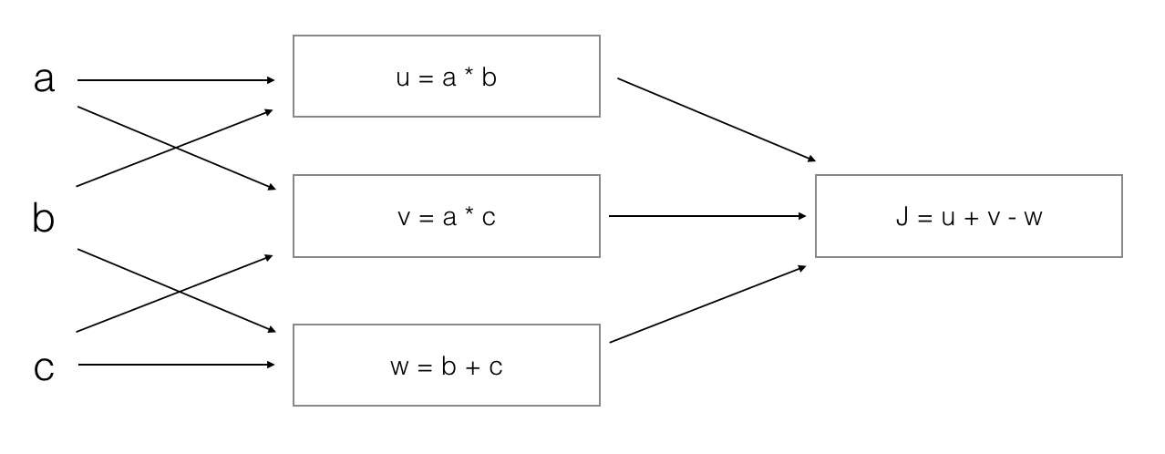

What is the output J?



J = (c - 1)*(b + a)



J = (a - 1) * (b + c)



J = a*b + b*c + a*c



J = (b - 1) * (c + a)

**Correct**

Yes. J = u + v - w = a*b + a*c - (b + c) = a * (b + c) - (b + c) = (a - 1) * (b + c).